Application Lifecycle Management (ALM)

How to add a new entry in the Assigned Team field.

by @glenn_a_allen

Go to your account settings drop down and choose Customize.

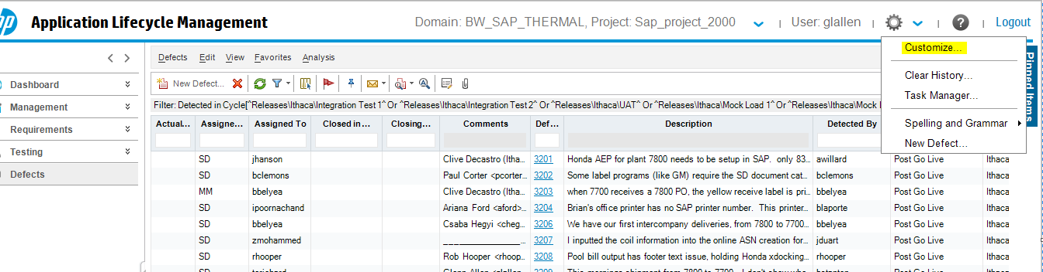

This screen will appear

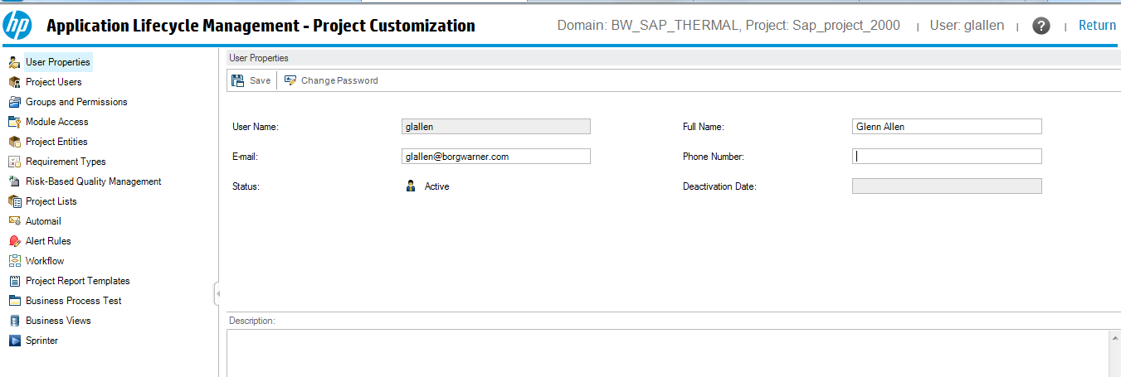Click on Project Lists/Assigned Team. Click New Item. Save and Return.

